1)Write a Script to Display Multiple Files Content to the Terminal and all File Names passed as Command Line Arguments?

Script:
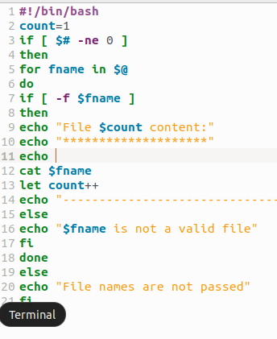
Output:

